Milestone 1

1. Team member

Wenting Zheng (wzheng8)

Yusi Qi (yqi3)

Tianming Liu (tliu18)

2. ER diagram

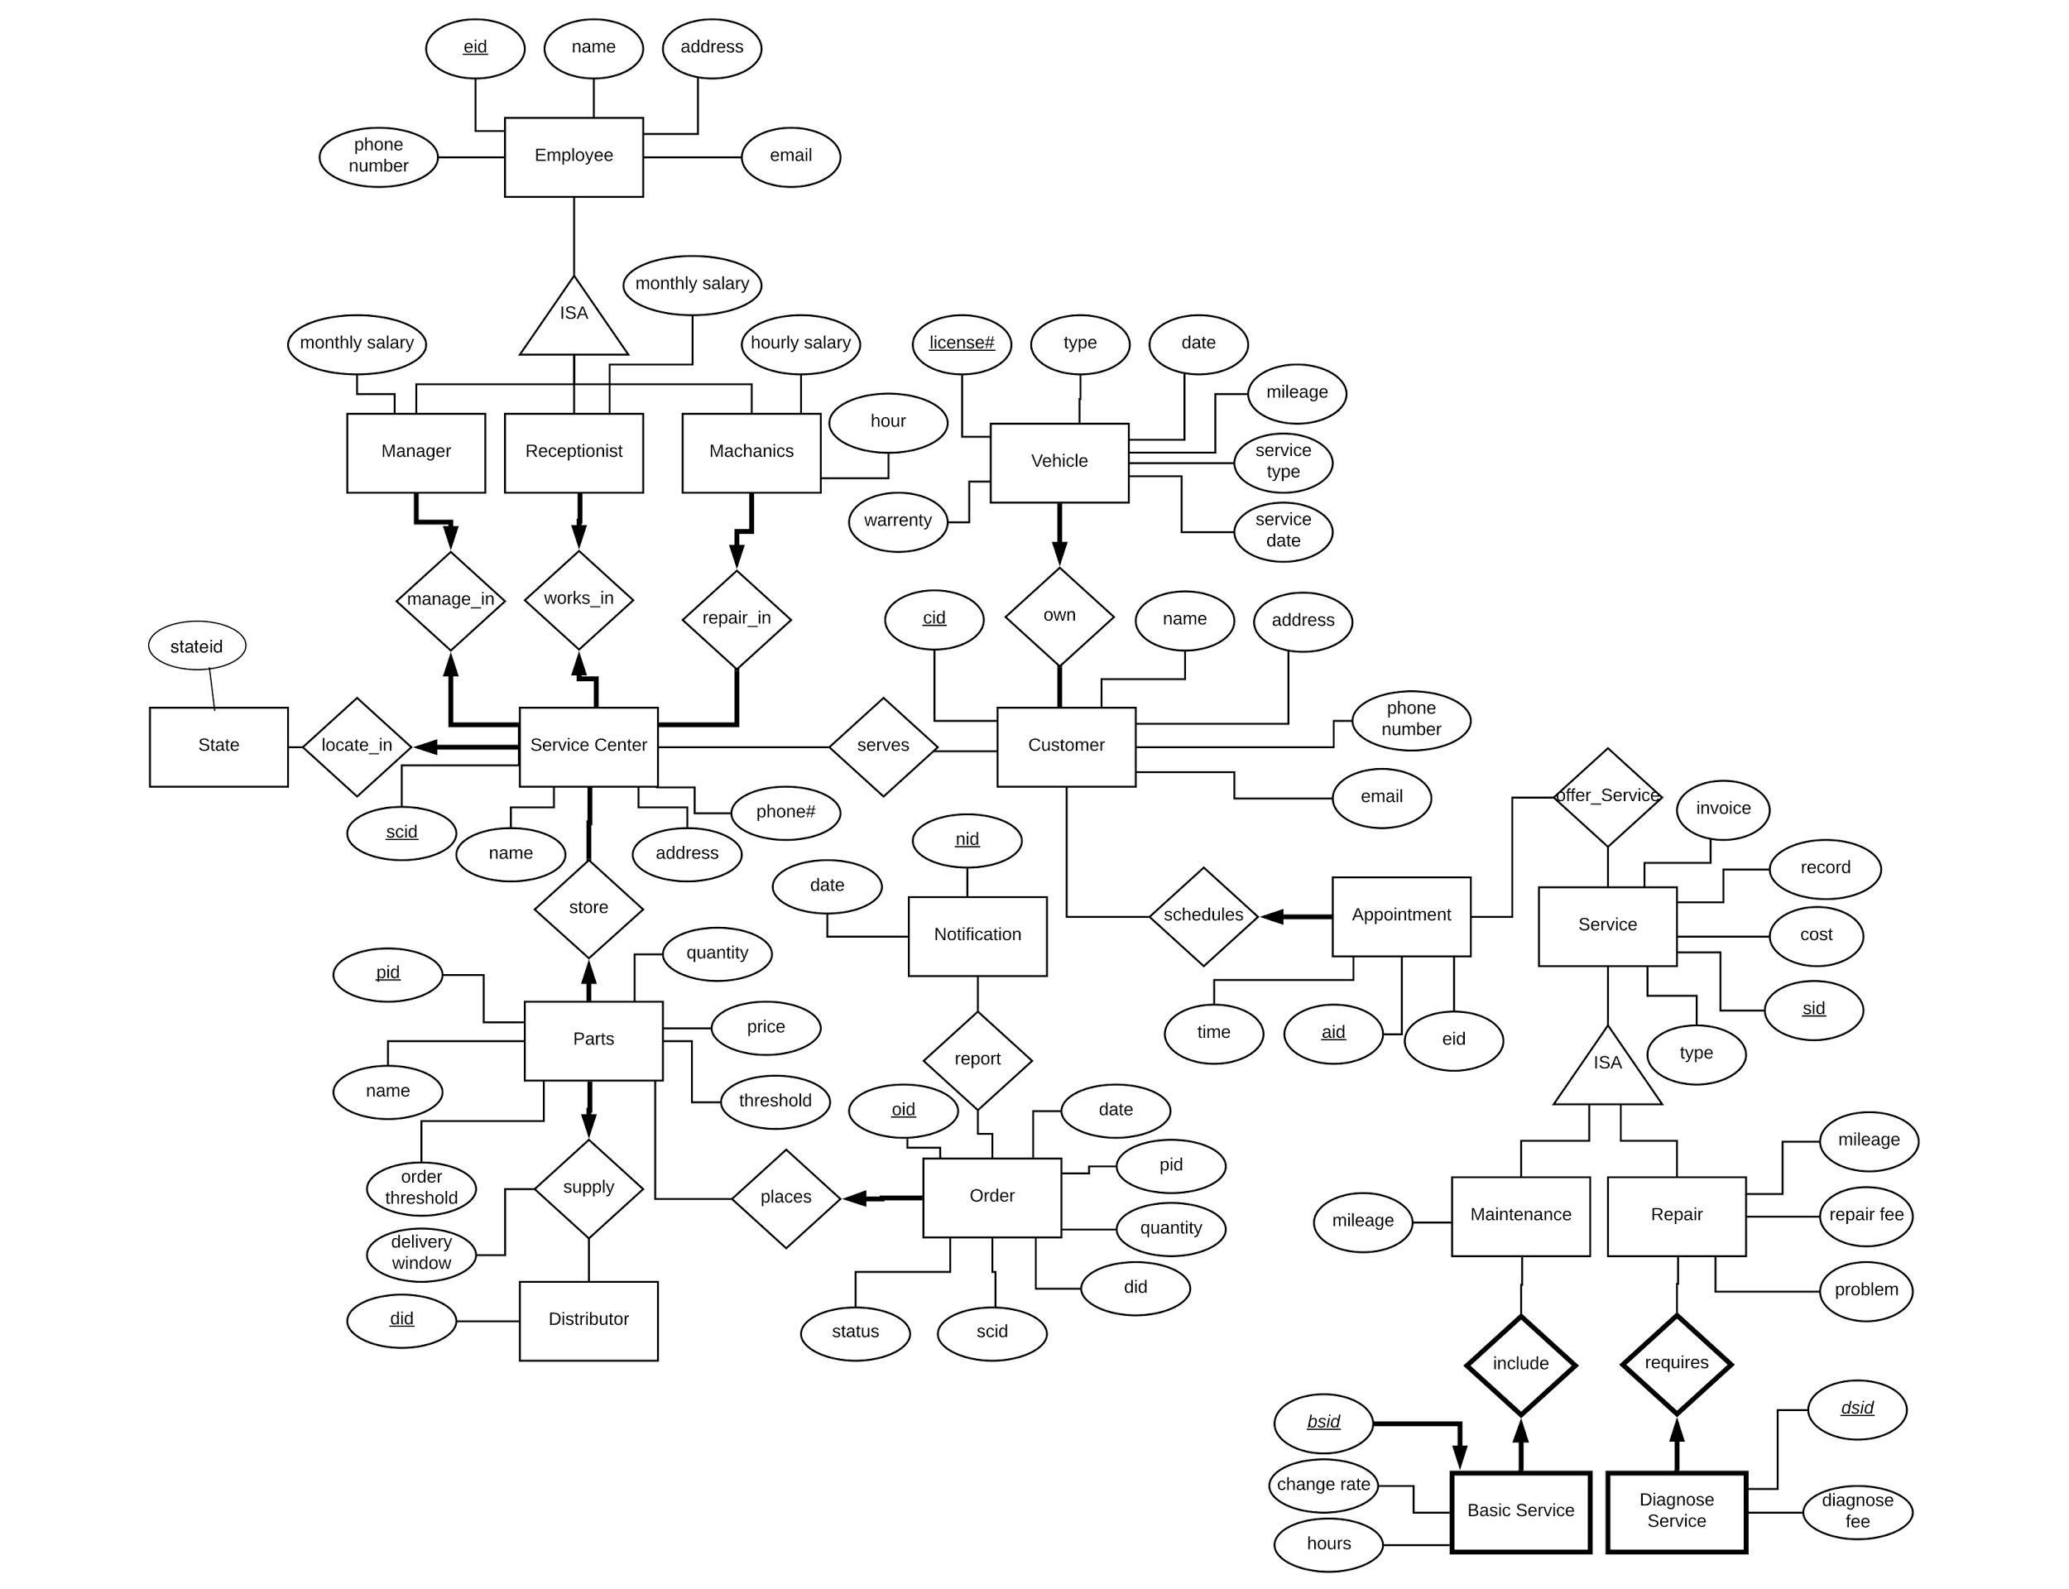

3. Tables & constraints

Instruction for reading the list of tables:

Relation tables are bold.

Primary keys are underlined

Foreign keys are italic.

Partial keys are bold and italic.

Bullet points are some comments, constraints, or discussions of decision made.

Tables:

State(stateid: integer);

* Constraint: Each state has 3 service center

**locates_in**(*stateid: integer, scid: integer*);

* Constraint: sid and scid are foreign keys from State and ServiceCenter tables respectively

ServiceCenter(scid: integer, name: string, address: string, phone number: integer);

* Constraints: each service center has one manager, one receptionist, and at least five mechanics

Employee(eid: integer, name: string, address: string, email: string, phone number: integer);

* Manager, Receptionist, and Mechanic has a ISA relationship with Employee with covering constraints.

Manager(monthly_salary: float);

**manages_in**(*scid: integer, eid: integer*);

* Constraint: scid and eid are foreign keys from ServiceCenter and Employee tables respectively

Receptionist(monthly_salary: float);

**works_in**(*scid: integer, eid: integer*);

* Constraint: scid and eid are foreign keys from ServiceCenter and Employee tables respectively

Mechanic(hourly_salary, hours: float);

**repairs_in**(*scid: integer, eid: integer*);

* Constraint: scid and eid are foreign keys from ServiceCenter and Employee tables respectively
* Decision about the wage:

If the wage is dependent on the role, the wage stays with the children tables. If the wage is dependent on the employee, the wage changes to the Employee table.

**stores**(*scid: integer, pid: integer*)

* Constraint: scid and pid are foreign keys from ServiceCenter and Part tables respectively

Part(pid: integer, name: string, quantity: integer, quantity threshold: integer, order threshold: integer, price: float):

**supplies**(*pid: integer, did: integer*, delivery window: string)

* Constraint: pid and did are foreign keys from Part and Distributor tables respectively

Distributor(*did: integer*);

**places**(*pid: integer, oid: integer*)

* Constraint: pid and oid are foreign keys from Part and Order tables respectively

Order(oid: integer, date: datetime, *pid: integer*, quantity: integer, *scid/did: integer*, *scid: integer*, status: string)

* pid and scid are the foreign keys from the Part, ServiceCenter tables respectively
* scid/did is the foreign key from either ServiceCenter or Distributor table. If there is a ServiceCenter with the demanded amount of parts, we use scid.

**report**(*oid: integer, nid: integer*)

* Constraint: oid and nid are foreign keys from Order and Notification tables respectively

Notification(nid: integer, date: datetime)

**serves**(*scid: integer, cid: integer*)

* Constraint: scid and cid are foreign keys from ServiceCenter and Customer tables respectively

Customer(cid: integer, name: string, email: string, address: string, phone number: integer)

**owns**(*cid: integer, license#: string*)

* Constraint: cid and license# are foreign keys from Customer and Vehicle tables respectively

Vehicle (license#: string, type: string, date: datetime, mileage: integer, service type: string, service date: datetime, warranty: boolean)

* Car type = Honda/Nissan/Toyota
* Each customer can have 0…* vehicles, but vehicle only has one owner.

**schedules**(*cid: integer, aid: integer*)

* Constraint: cid and aid are foreign keys from Customer and Appointment tables respectively

Appointment(aid: integer, time: datetime, *eid: integer*)

* eid is foreign key from Employee table

**offer_service**(*aid: integer, sid: integer*)

* Constraint: aid and sid are foreign keys from Appointment and Service tables respectively

Service(sid: integer, record: string, cost: float, invoice: string, type: string);

* Decision about the 3 types of services:

If the 3 types contains information more than the required mileage, we will create a table for Service_A, Service_B, and Service_C. If the 3 types only contains mileage, we will leave it as an attribute of Service entity.

Maintenance(mileage: integer);

Repair(mileage: integer, repair fee: float, problem: string);

* Constraint: Maintenance and Repair has a ISA relationship with Service with covering constraints.

**requires**(*sidR: integer, dsid: integer*)

* Constraint: sidR and dsid are foreign keys from Service and DiagonosticService table.

DiagnosticService(***dsid: integer***, fee: float);

* Constraint: the Diagnostic service is a weak entity of Repair

**includes**(*bsid: integer, sid: integer*)

* Constraint: bsid and sid are foreign keys from BasicService and Service tables respectively

BasicService(***bsid: integer***, hours: float, charge rate: float);

4. Application constraints and functional dependencies

Constraints:

Service Center details

Car type = Honda/Nissan/Toyota

Every state has three service centers

Opening hours: 5 days a week (M-F) from 8 AM to 7 PM

Each center has a manager, a receptionist and at least five mechanics

Employees

Role: manager, receptionist, and mechanic.

Works at only one service center

Mechanics are paid hourly

Get paid 1st and 15st

Customers

Each customer has 0 or more cars, but each car only has one owner (WEAK ENTITY?)

No cost of the repair with warranty, but there is still diagnostic service cost

The cost is dependent on the times of the

Car and Service details

Each service center has three type of service: Type A, Type B, Type C.

Each service including 0 or more basic services.

Basic service has two charge rate, but each basic service has only one charge rate.

Type B service includes Type A services and Type C service includes Type B services.

Repair services include a specific problem reported by the customer, a diagnostic service and fee, and then the actual repair and fees (parts and labor).

Appointment

Each of appointment only contains only one car.

Scheduling of appointments tries to ensure that no more than half the day is allocated to maintenance requests.

Inventory

Each part in the inventory requires a minimum threshold.

Functional dependencies:

The miles of car determines the type of the service.

Basic service type determines the charge rate.

Cost of the service determine the times of the specific type of service

A successful scheduling appointment requires an available time slot of the service and available parts.

The quality of parts want to order dependencies on the number of parts are desired and the number of the parts in threshold.

5. Questions:

1. The paycheck is generated on 1st and 15st each month for all employees or for only hourly paid mechanics?
2. Is the wage dependent on the employee? Or the position of the employee? In the other word, will all the managers get the same wages?